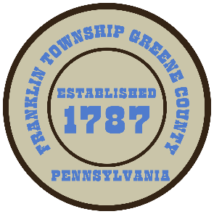
Franklin Township
568 Rolling Meadows Road
P.O. Box 752
Waynesburg, PA 15370
724-627-5473

AGENDA
APRIL 22, 2024

- Public Comment

- Wash-Rite Car Wash Site Plan Review-Motion

- Surface Use Easement Agreement between Franklin Township and Equitrans Water Services, (PA), LLC

- Adopt the Franklin Township Employee Handbook and Policy Manual

- Motion to Advertise for Township Position-Road Maintenance

- Motion to Approve Invoices Presented for Payment

- Motion to Approve Minutes-Previous Regular Meeting

- Motion to Adjourn

