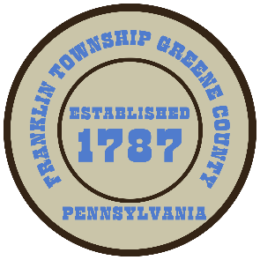

**Franklin Township**

**568 Rolling Meadows Road**

**P.O. Box 752**

**Waynesburg, PA 15370**

**724-627-5473**

**AGENDA**

**July 08, 2024**

* Public Comment
* Bid Opening-Crawford Park Paving Project
* Motion to Approve Ordinance #02-2024 Road Closure -TR492 (Old Route 21 Rd) Approx. 0.09 miles
* Motion to Purchase F-150 Crew Cab Truck from Fox Ford, through CoStars
* Motion to Approve Invoices Presented for Payment
* Motion to Approve Minutes-Previous Regular Meeting
* Motion to Adjourn