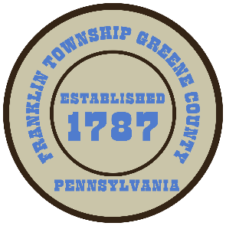

**Franklin Township**

**568 Rolling Meadows Road**

**P.O. Box 752**

**Waynesburg, PA 15370**

**724-627-5473**

**AGENDA**

**September 09, 2024**

* Public Comment
* Opening of Bids for Tollgate Run Road Property Demolition
* Motion to Approve Fox-To-Fox Split
* Motion to Approve the Novation Agreement with NEI Pennsylvania, LLC an affiliated company with Westmoreland Sanitary Landfill, LLC for municipal waste collection.
* Motion to Approve the P.M.R.S. 2025 Pension Plan MMO Worksheet.
* Schedule the 2024 Fall Clean Up Day for October 4th and October 5th.
* Motion to Approve Invoices Presented for Payment
* Motion to Approve Minutes-Previous Regular Meeting
* Motion to Adjourn