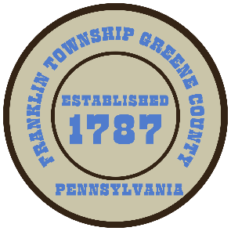

**Franklin Township**

**568 Rolling Meadows Road**

**P.O. Box 752**

**Waynesburg, PA 15370**

**724-627-5473**

**AGENDA**

**December 09, 2024**

* Public Comment
* Motion to Accept Bids once they become available for Hill School House Rd Phase I of C.D.B.G. prepared by Bankson Engineering. Projected Bid Opening Jan. 13, 2025
* Motion to Approve Invoices Presented for Payment
* Motion to Approve Minutes-Previous Regular Meeting
* Motion to Adjourn