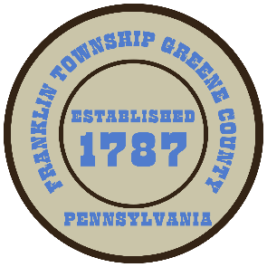

**Franklin Township**

**568 Rolling Meadows Road**

**P.O. Box 752**

**Waynesburg, PA 15370**

**724-627-5473**

**AGENDA**

**December 23, 2024**

* Public Comment
* Motion to Pass the 2025 Budget for Franklin Township
* Motion to Approve Sales Agreement Between Franklin Township and Commonwealth of PA to covey a portion of the Waynesburg Drivers License Center Property.
* Motion to Reappoint Charlie Riggs to the Franklin Township Sewer Authority Board
* Motion to Approve Invoices Presented for Payment
* Motion to Approve Minutes-Previous Regular Meeting
* Motion to Adjourn