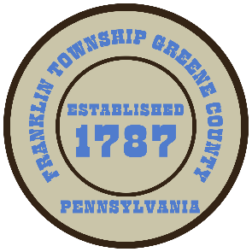

**Franklin Township**

**568 Rolling Meadows Road**

**P.O. Box 752**

**Waynesburg, PA 15370**

**724-627-5473**

**AGENDA**

**January 13, 2025**

* Public Comment
* Bid Opening for C.D.B.G. Program-Hill School House Phase I Waterline
* Motion to Approve Invoices Presented for Payment
* Motion to Approve Minutes-Previous Regular Meeting from December 23, 2024
* Motion to Approve-Minutes from the January 06, 2025 Reorganization meeting
* Motion to Adjourn