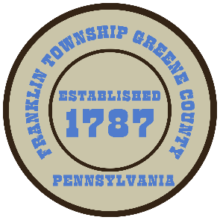

**Franklin Township**

**568 Rolling Meadows Road**

**P.O. Box 752**

**Waynesburg, PA 15370**

**724-627-5473**

**AGENDA**

**January 27, 2025**

* Public Comment
* Motion to Move Forward with the process of the C.D.B.G.-Hill School House Waterline Project
* Motion to Approve Invoices Presented for Payment
* Motion to Approve Minutes from the previous meeting
* Motion to Adjourn