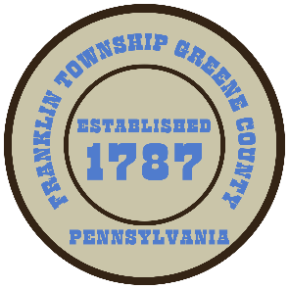

**Franklin Township**

**568 Rolling Meadows Road**

**P.O. Box 752**

**Waynesburg, PA 15370**

**724-627-5473**

**AGENDA**

**February 24, 2025**

* Public Comment
* Motion to Purchase 2025 Ford Super duty Truck through Fox Ford Costars Program
* Motion to Purchase Upfit Package for 2025 Ford through Fox Ford Costars Program
* Motion to Purchase Hydraulic Spreader through Chemung Supply
* Motion to Purchase 10 cubic yd Leaf Vac through Stephenson Equip. Costars Program
* Motion to Approve proposed modification for the use of the 2024 CDBG funds for Hill School House Road
* Motion to Approve Invoices Presented for Payment
* Motion to Approve Minutes from the previous meeting
* Motion to Adjourn