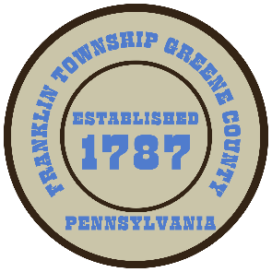

**Franklin Township**

**568 Rolling Meadows Road**

**P.O. Box 752**

**Waynesburg, PA 15370**

**724-627-5473**

**AGENDA**

**March 10, 2025**

* Public Comment
* Motion to Approve Roadway Lighting Agreement for SR-2003-U20 Sugar Run Intersection
* Motion to Approve Resolution #01-2025 Roundabout Roadway Lighting Agreement
* Motion to Approve Hold Harmless Agreement for Wbg. Borough Rainday Festival with Starfire Corporation
* Motion to Approve Stephenson/Fox-To-Fox Lot Split/Deed of Incorporation
* Motion to Approve Stephenson/Fox-To-Stephenson Lot Split/Deed of Incorporation
* Motion to Approve Invoices Presented for Payment
* Motion to Approve Minutes from the previous meeting
* Motion to Adjourn